**HWK 3: MongoDB**

Name: Jithendhar Karukola

Email: jkarukol@stevens.edu

CWID: 20021858

1. Please find out how many posts from account “eBay” and “Disney” and have “Likes” larger than 10

**MQL:**

db.hwk_fb..aggregate([

{ $match: { $or: [{ "Page Name": "eBay" }, { "Page Name": "Disney" }], Likes: { $gt: 10 } } }, { $group: { _id: "$Page Name", count: { $sum: 1 } } }])

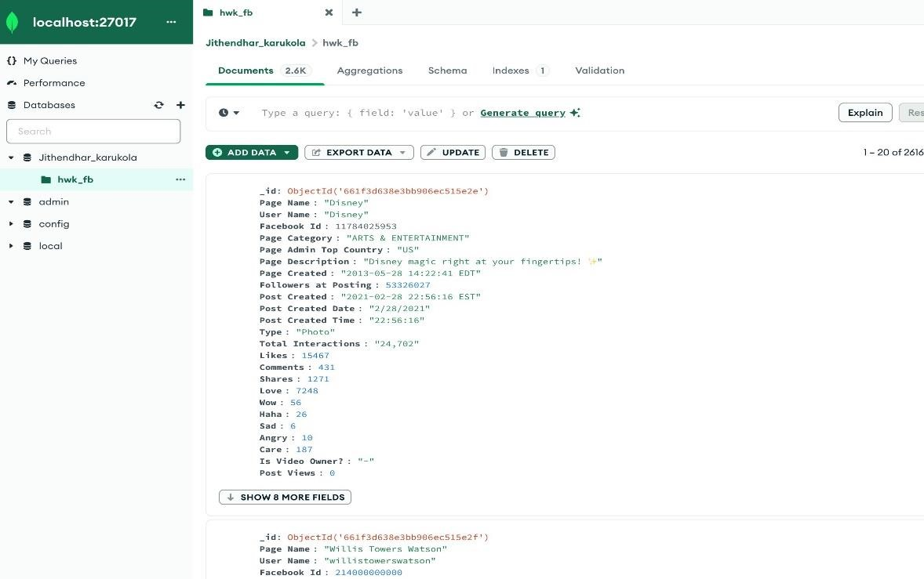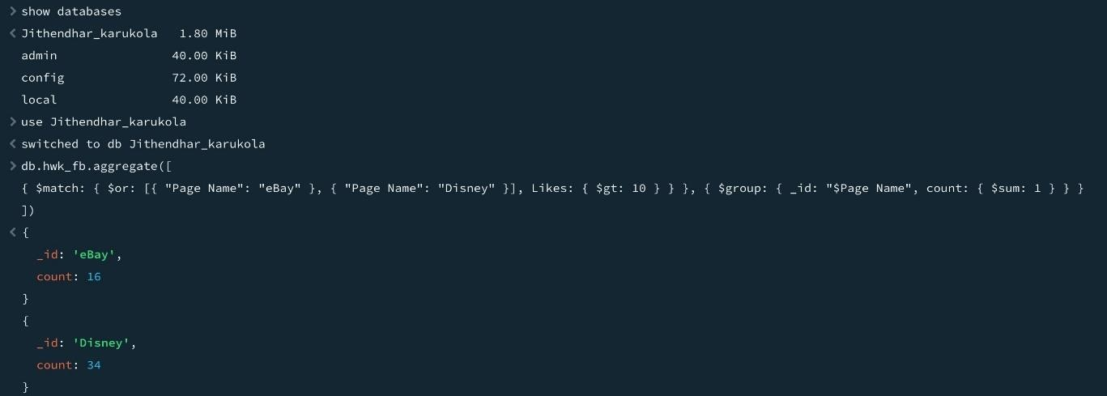

1. Please find out how many posts have “Likes” larger than 3 or “Shares” larger than 5, and the output only display the “Page Name”, “Likes”, and “Shares” (If the data type of “Shares” is a string, you need to change the data type of “Shares”)

**MQL:**

db.hwk_fb.find(

{ $or: [{ Likes: { $gt: 3 } }, { Shares: { $gt: 5 } }] },

{ "Page Name": 1, Likes: 1, Shares: 1, _id: 0 }

).count()

**MQL Output:**



1. Please find out the Top 3 Facebook accounts which have the largest number of “Likes” (you need to only display the “Page Name” and “Likes” of these accounts)

**MQL:**

db.hwk_fb.aggregate([

{ $group: { _id: "$Page Name", totalLikes: { $sum: "$Likes" } } },

{ $sort: { totalLikes: -1 } },

{ $limit: 3 },

{ $project: { "Page Name": "$_id", Likes: "$totalLikes", _id: 0 } }

])

**MQL Output:**



1. How many documents in this collection have the field “Image Text”?

**MQL:**

db.hwk_fb.countDocuments({"Image Text":{$exists:true}})



1. For those accounts with names starting with the letter “d” or ending with "d", please find out the Top 3 Facebook accounts which have the largest value of “Interaction Ratios”. (Interaction Ratios = (“Likes” + “Shares”) / “Total Views”) (you need to only display “Page Name” and all the fields you created in this step).

**MQL:**

db.hwk_fb.aggregate([

{ $match: { $or: [{ "Page Name": /^d/ }, { "Page Name": /d$/ }] } },

{

$addFields: {

InteractionRatio: {

$cond: { if: { $or: [{ $eq: ["$Total Views", 0] }, { $eq: ["$Total Views", null] }, { $eq: ["$Total

Views", undefined] }] }, then: 0, // Handle division by zero by setting

InteractionRatio to 0 else: { $divide: [{ $add: ["$Likes", "$Shares"] }, "$Total Views"] }

}

}

}

},

{ $sort: { InteractionRatio: -1 } },

{ $limit: 3 },

{ $project: { "Page Name": 1, InteractionRatio: 1, _id: 0 } }

])

